**LAB # 12**

##### Lab Tasks

**Task # 01:** Train the Artificial Neural Network using the dataset provided in the lab.

Solution:

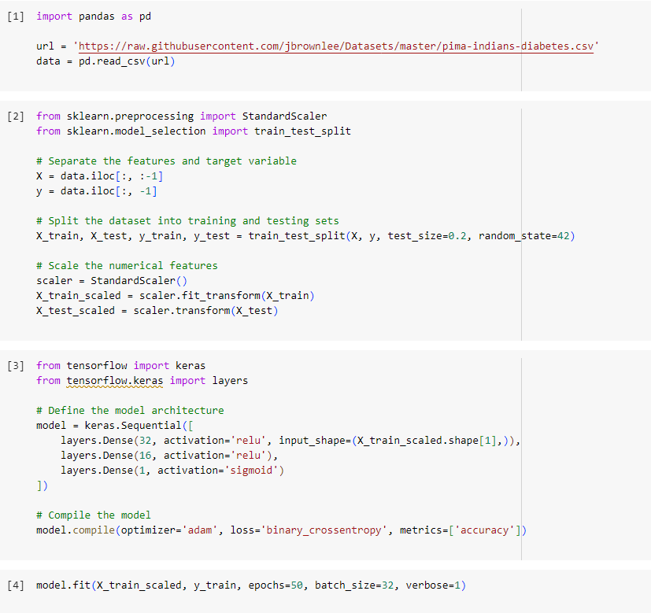

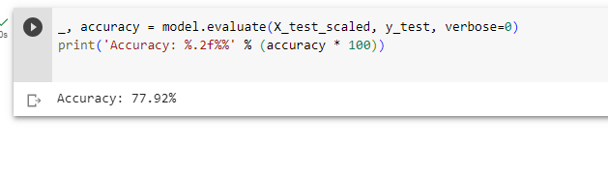

**Task # 02:** Train the Artificial Neural Network using the iris dataset and discussed the results.

Solution:

